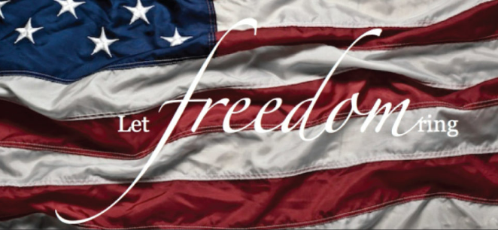

Promote Patriotism
When singing our National Anthem or saying the Pledge of Allegiance on patriotic holidays it reinforces the value of our freedom as American citizens.
By passing our patriotism on to the
next generations we instill pride
while honoring Patriots and our Country.

It is officially “school sport season” so be sure to sing YOUR National Anthem LOUD AND PROUD at all the games you attend.

Lead by example!

November Americanism Report

Sally Lamers
24-25 Department of WI
VFWA Patriotic Instructor and Americanism Chair

1861 Oakridge Road, Neenah, WI 54956
sslamers@gmail.com
920.475.0789 *please leave a message*

https://malta.vfwauxiliary.org/MemberResources/Americanism

